Minor Project

Web Development

Name: Mohit Agarwal

Batch: February 2023

**Historical Places in India**

***Languages used***: Html, CSS

***Framework***: Bootstrap

***GitHub Repository:*** (<https://github.com/Suke-ag/india>)

***Website Link***: (<https://suke-ag.github.io/india/>)

***Source Code:***

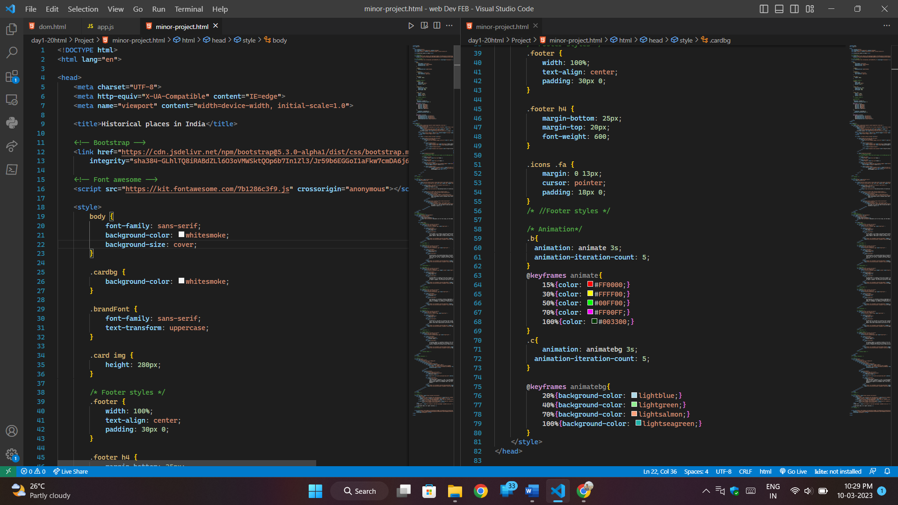

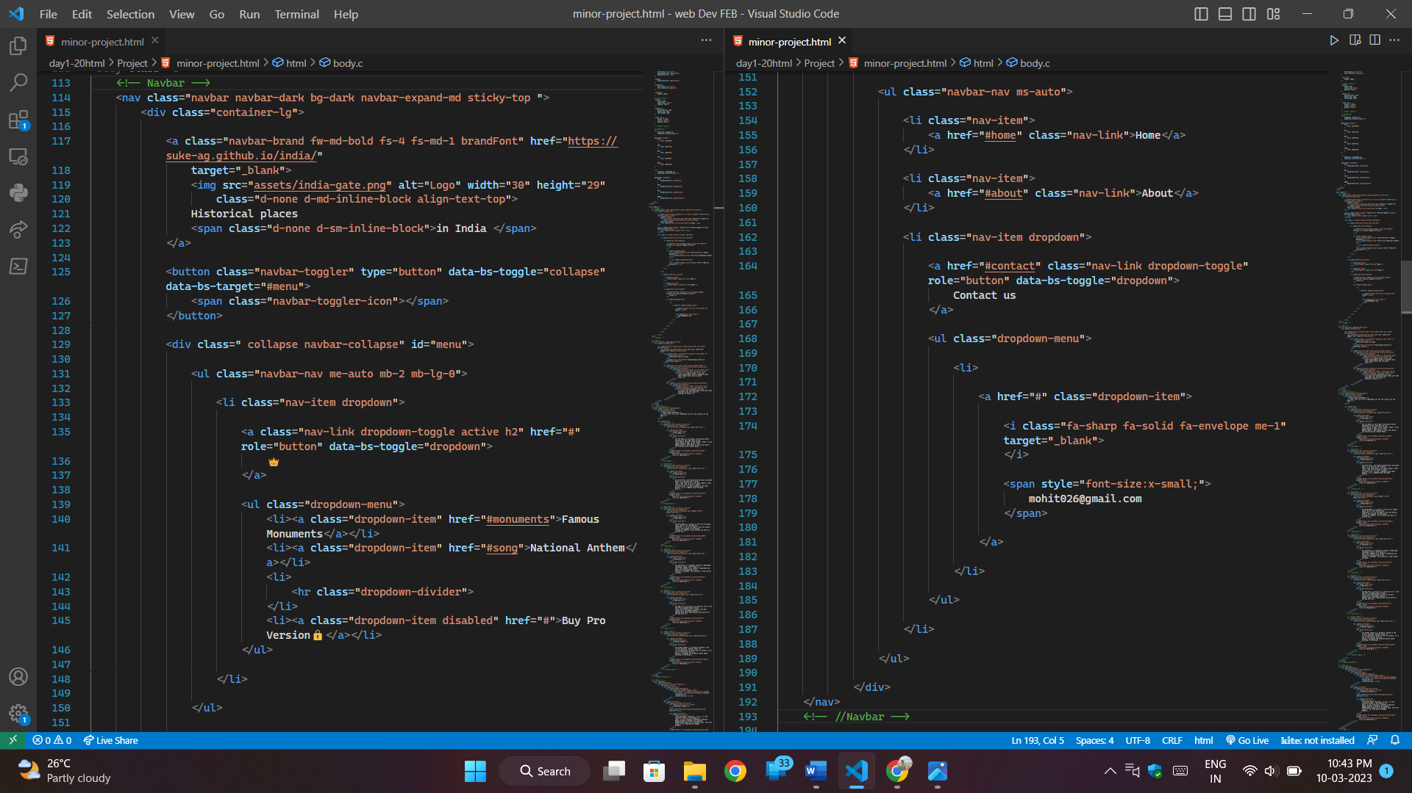

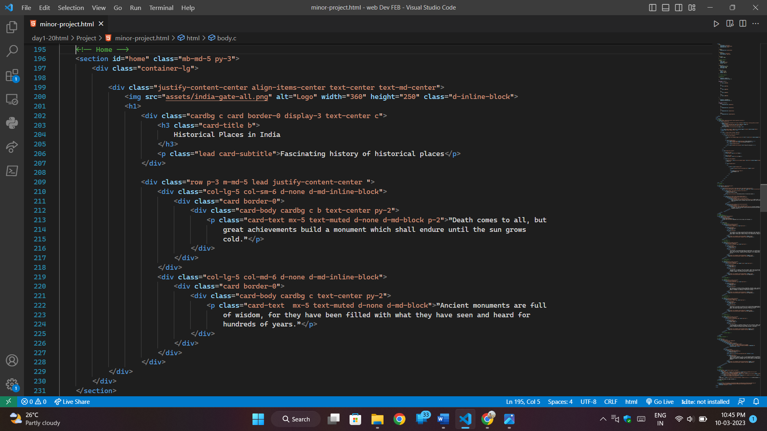

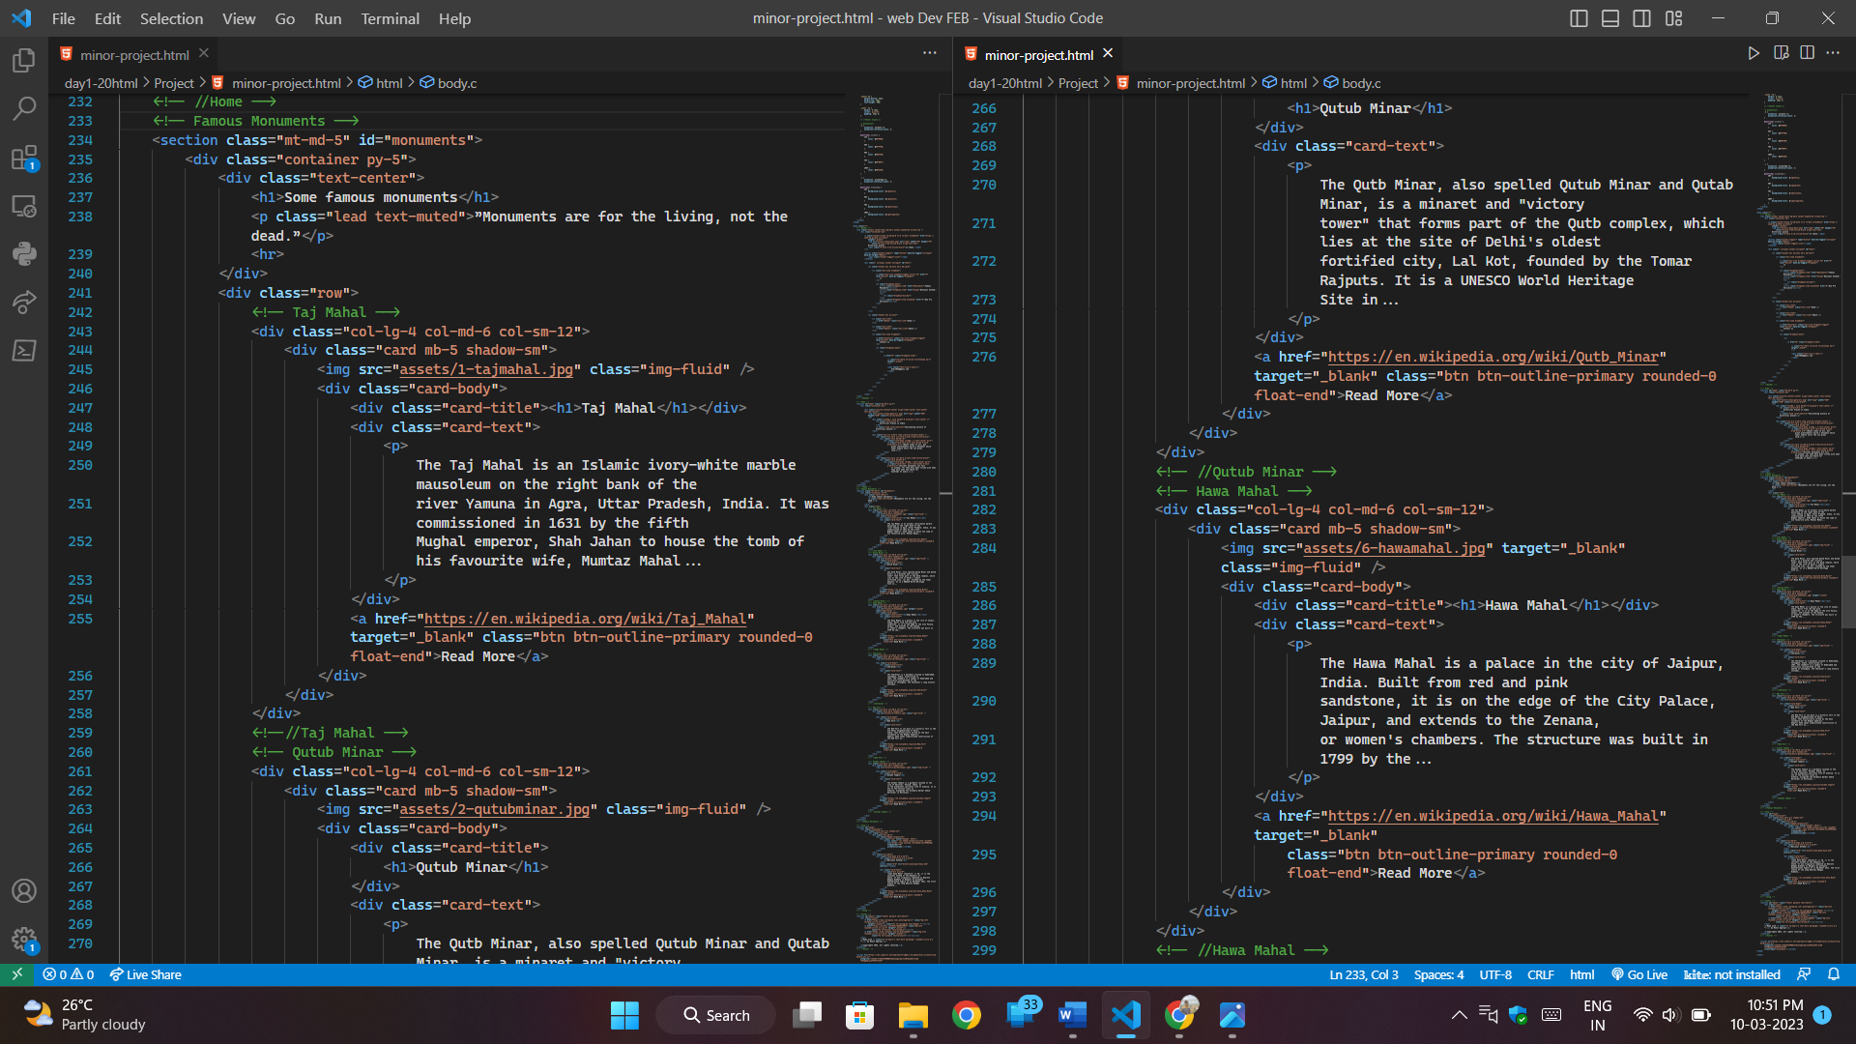

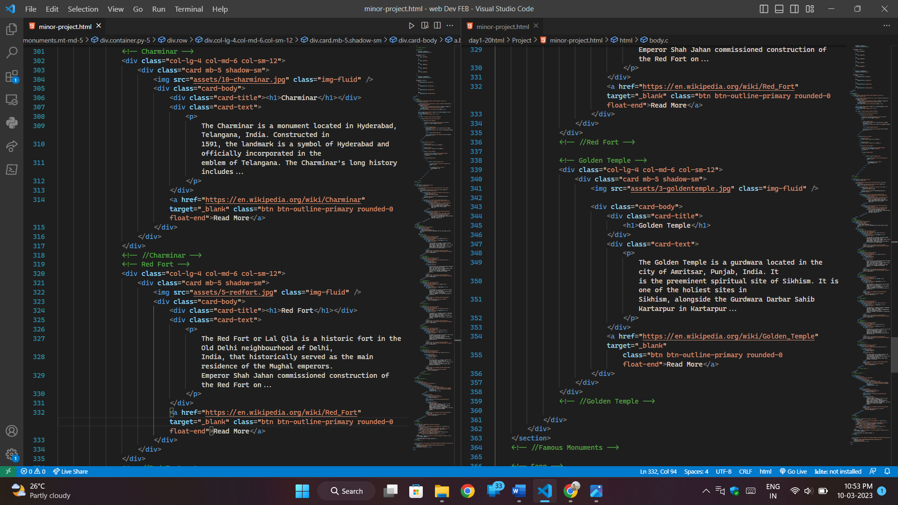

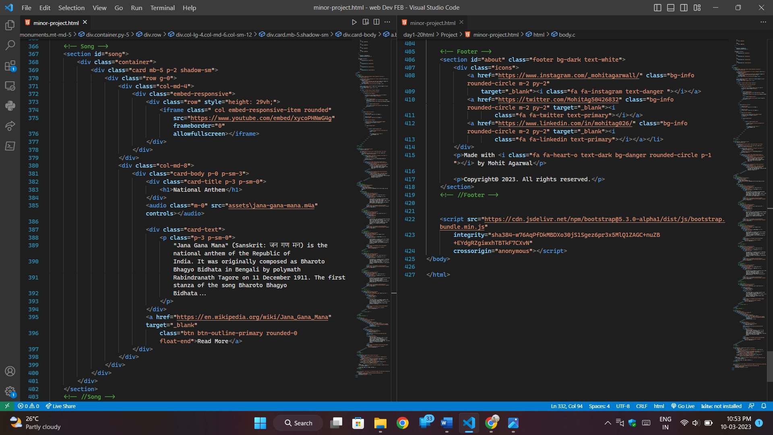

***Snapshots of Website on Mobile:***

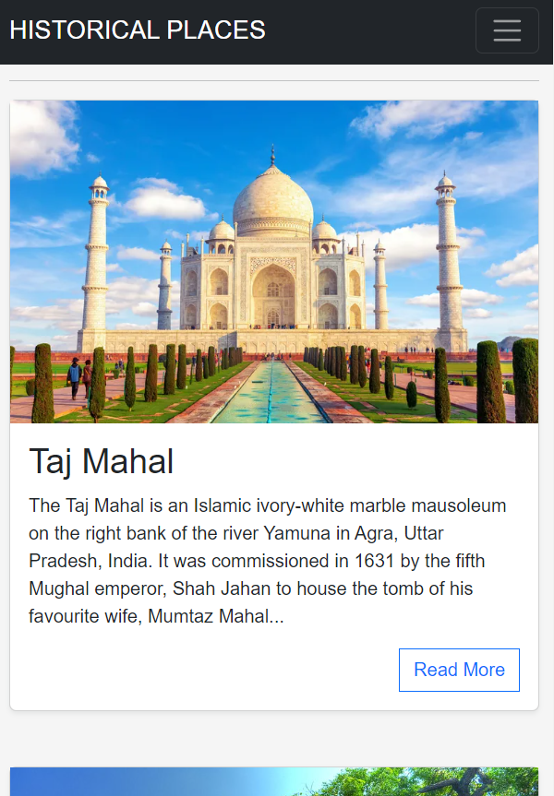

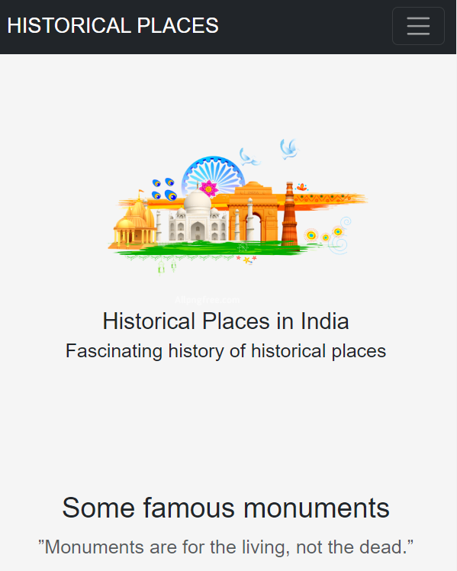

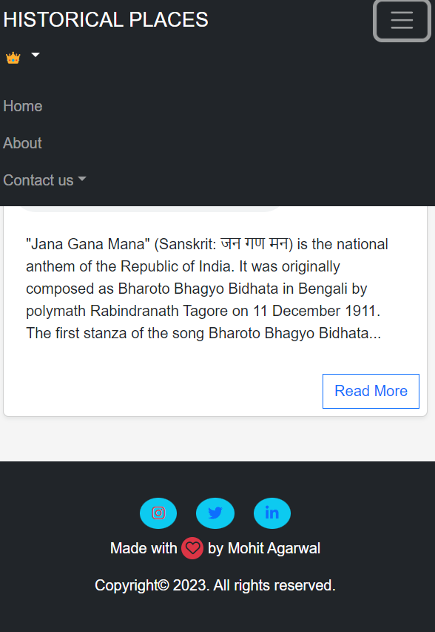

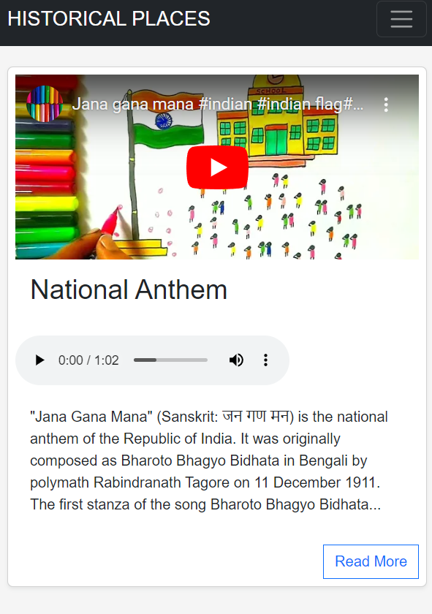

**1. Landing Page on Mobile 2. Famous Monuments**

**3. National Anthem 4. Navbar & about us**